**IBM Cloud Services**

|  |  |
| --- | --- |
| Team Id | PNT2022TMID16026 |
| Project Name | Smart Farmer – IOT Enabled Smart Farming Application |

**Dash Board**

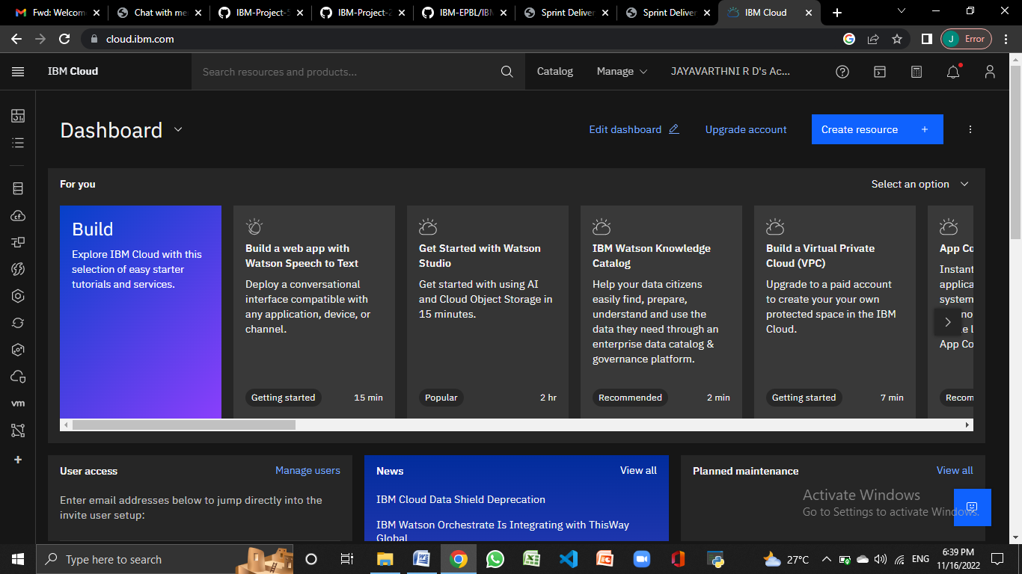

**Account Settings**

